



ArcGIS Collector  
and Survey123

## Coupon Test Station

User Guide For Androids



**Table of Contents**

**Collector by ArcGIS Online**

Overviews and Tutorials 3

How to Open ArcGIS 4

How to Open Survey123………………………………………………………………………….5

How to Open CTS Locations Map…………………………………………………………….6

Home Screen Menu 7

Map Library 9

Map Layers and Basemaps. 11

Location Search 12  
**Upload and Sync Offline Maps 13**  
**Collecting Data with Collector 17**  
Symbols 18

Editing Data 19  
**Inspectors Only - Collecting Data with Survey123. 22**Inspectors Only - Collecting Data 23  
Inspectors Only - Sending Data (online)………………………………………………….24  
Inspectors Only - Sending Data (offline)………………………………………………….25  
**General Workflow. 26****Links and Resources 27**

# Overviews and Tutorials

ArcGIS Collector and Survey123

### Summary

Below are step-by-step instructions for downloading, signing-in, and launching the ArcGIS Online app.

1. 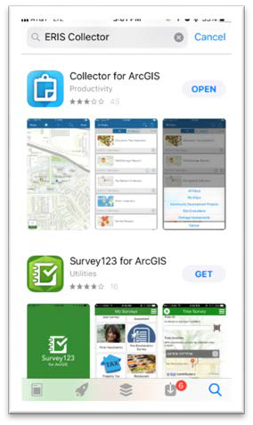If needed, download Collector App by searching ESRI Collector in the App Store.



Basema pLibrar

y

1. Start Collector App and sign in to ArcGIS Online.

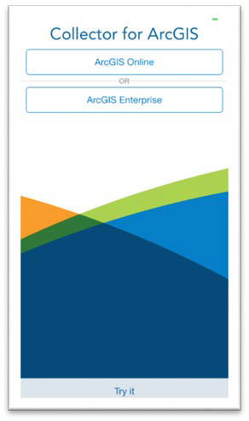 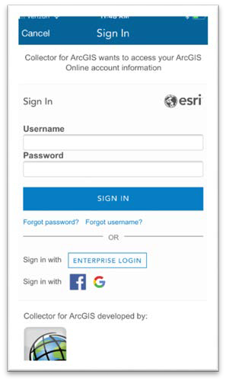  
 Select ArcGIS Online Sign-in



**How to Open ArcGIS Online**

**Overview**



**How to Open Survey123**

**Overview**

### Summary

Below are step-by-step instructions for downloading, signing-in, and launching the Survey123 app.

1. If needed, download the Survey123 App by searching Survey123 in the App Store.





2. Start the Survey123 App and sign in 3. Select Pipe Inspection Form

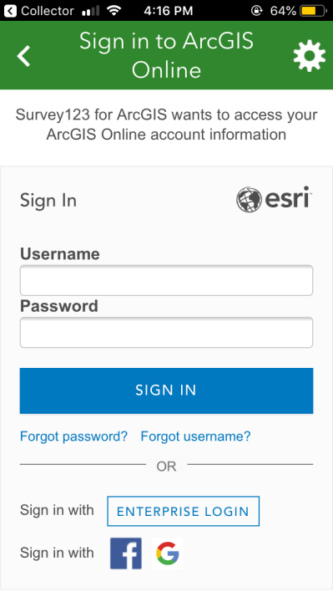 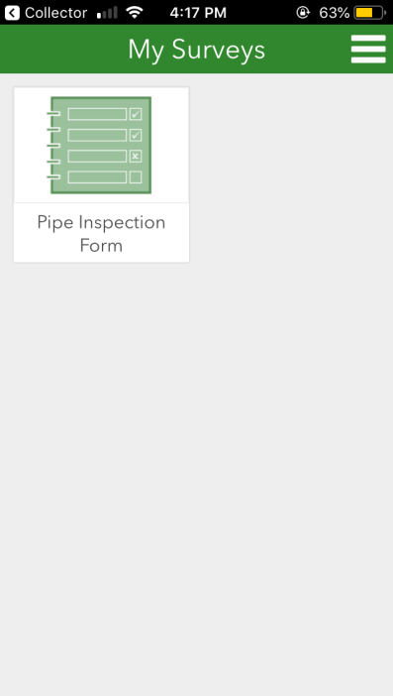

- Note: Surveys are device specific.

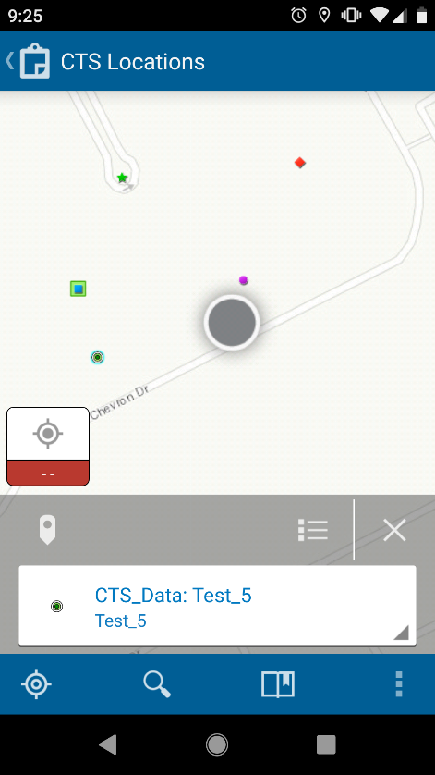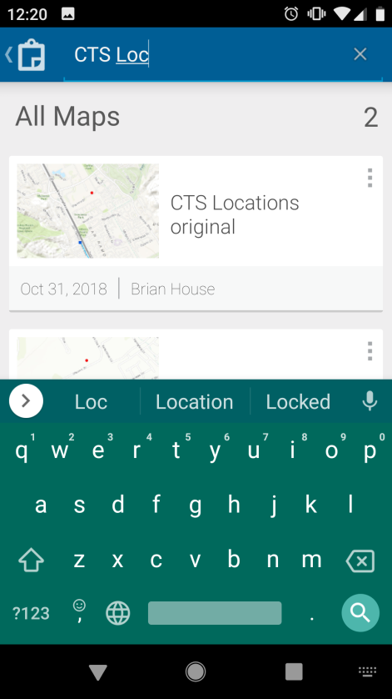1. Search and open CTS Locations 2. The map will open and center on your location.



**How to Open CTS Locations Map**

**Overview**

**GPS On**

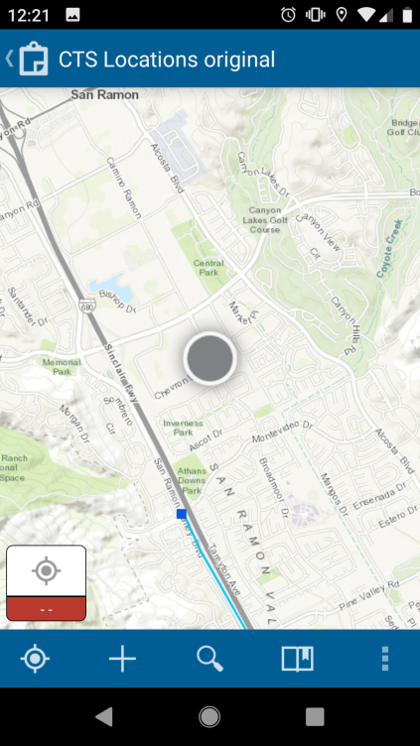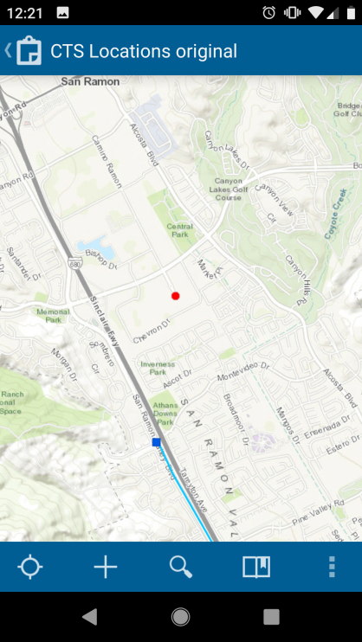

When the ‘Current Location’ icon is highlighted white, the GPS finder is on.

**GPS Off**

When the icon is not highlighted white,

the GPS tracker is off.

**How to Open ArcGIS Online**

**Overview**

### Summary

This is an overview of the ArcGIS Online for mobile interface.

Map Gallery

Location Accuracy

Current Location Overflow

Add Feature Search Bookmark

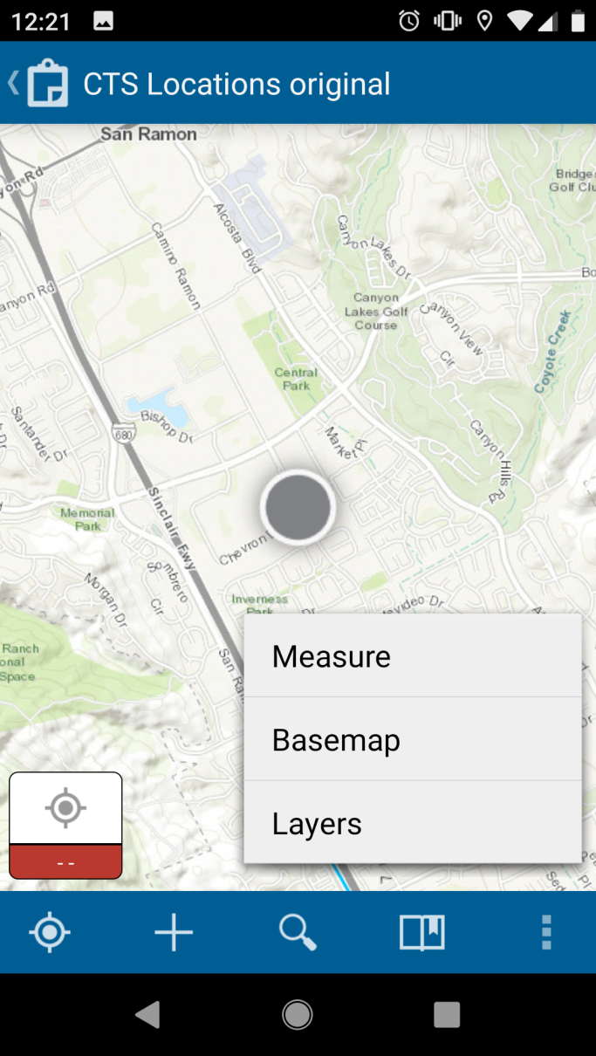



**Home Screen Menu**

**Overview**



**Home Screen Menu**

**Overview**

  **Overflow** Expands toolbar and shows the additional tools



**Current Location**



Center map on your current location



**Bookmarks**



**Measuring Tool**



Access Measurement Toolkit



**Basemaps**













  **Add a feature** Create new point, polygon, or line

******Accuracy Integration** Horizontal and Vertical Accuracy

### Summary

**Map Library**

**Overview**

This is where all your maps are stored. You’ll have the option to store the map on your device.

#### Map Library Toolbar

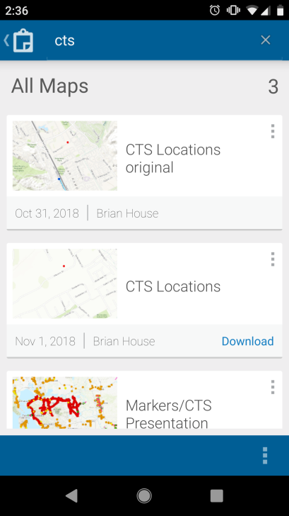 All Maps Stored Maps



**Map Library**

**Overview**

Map Details

Download

Overflow/Account Settings



**Stored Maps**



Toggle between Cloud-Based and On Device

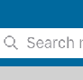

**Search Maps**



**Download to Device**



Store Maps on Device for ‘offline use’







**Map Details** View map and survey details



**Map Library**

**Overview**

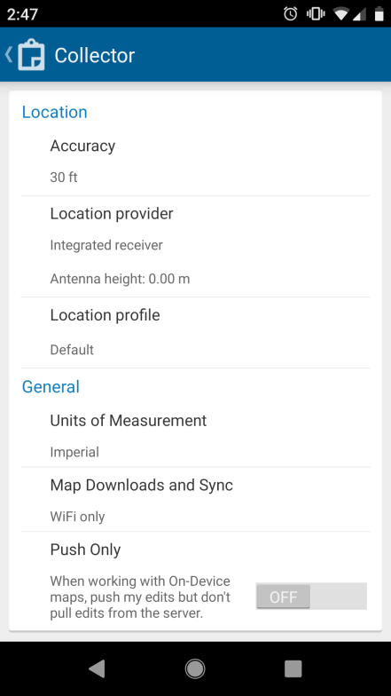

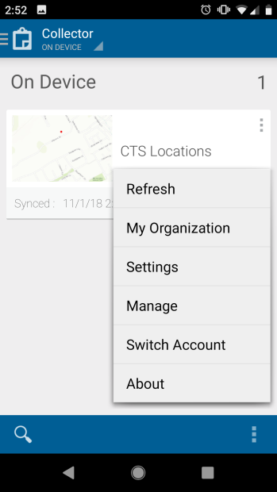

* + Syncing of offline data should be available via wifi or cellular data.
  + These can be configured in settings on the home screen.
  + Open Settings and scroll down to General
  + Select Maps Downloads and Sync
  + Select Wifi or Cellular

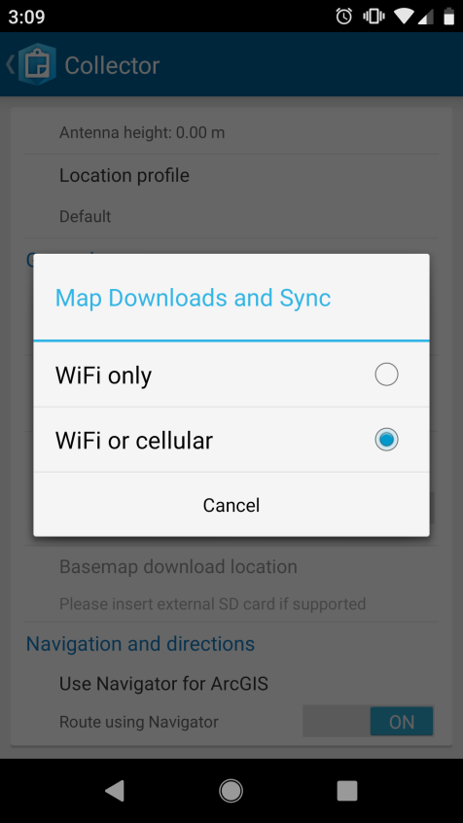



**Map Layers and Basemaps**

**Overview**

The available layers to view are CTS: Proposed, CTS: RFI Pending, CTS: USA Scouted, CTS: Installed, CTS: Inspection Complete, CTS: Existing/Repaired, ETS, PG&E Gas Transmission, City County Boundaries, and Parcels. If the blue circle to the left of the layer option is checked and blue, the layer is turned-on and will appear on the map.

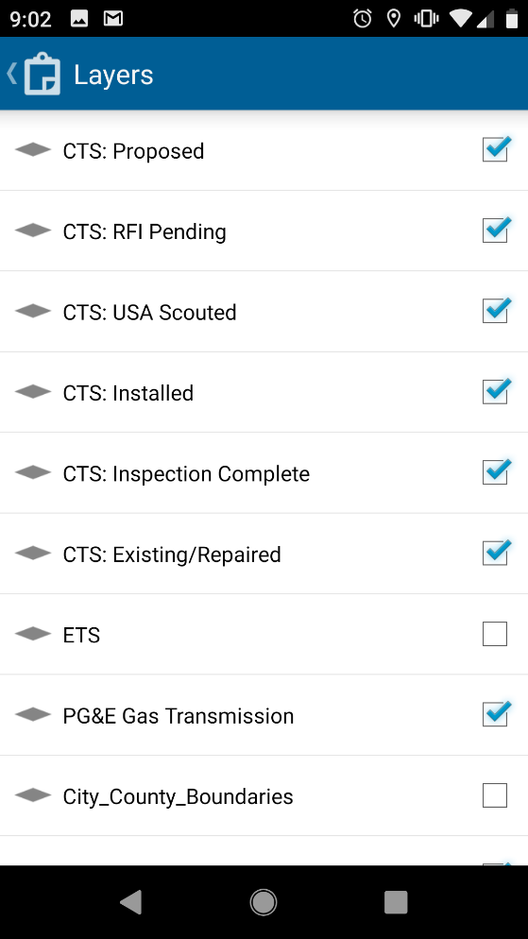

If connected to WIFI or mobile data (not working ‘On Device’) you can access any ESRI basemap at any time. While connected to WIFI or mobile data, you can store basemaps to be used when working ‘On Device’. This is where you can change the display type of the map that appears on your screen.

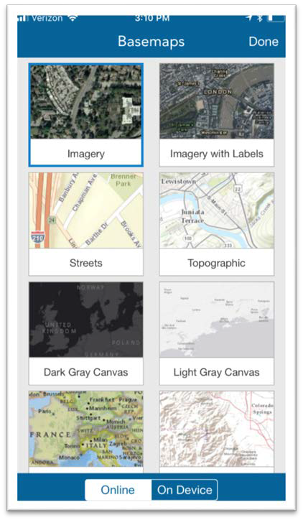

Online/On Device Toggle



**Location Search**

**Overview**

### Summary

This is where you can search for places, addresses, or specific CTS locations. Once you enter the place or address you would like to locate, the map will adjust accordingly. The search can be removed by selecting the ‘x’ mark within the search bar.

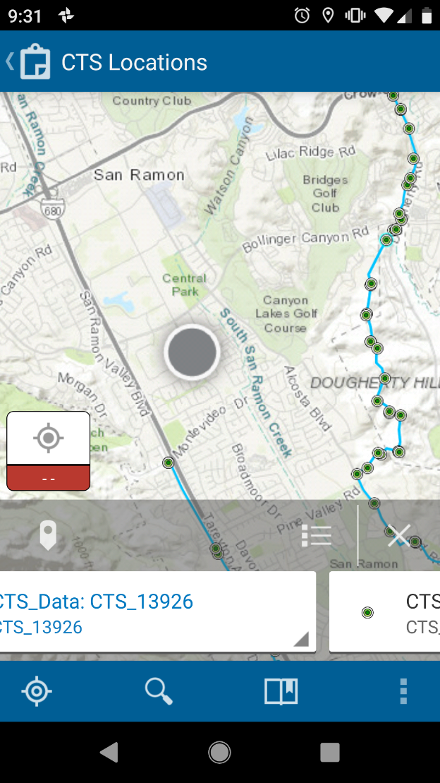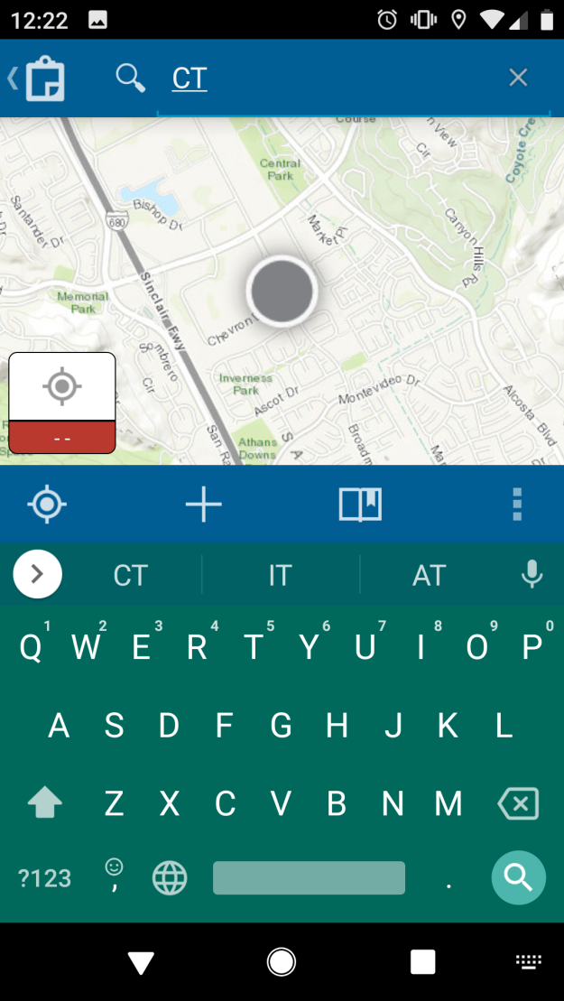

Upload and Sync Offline Maps

ArcGIS Collector



**Upload/Sync Offline Maps**

Summary

If you are working in a remote area with limited cellular service, you can download a map to work offline to work ‘On Device’. If offline or working ‘On Device’, after you have re-established cellular service, you will need to go back to the ‘Maps’ menu under ‘On Device’ and click ‘sync’ these features to ArcGIS Online. This requires cellular data or WIFI connection.

Downloading a map for offline use

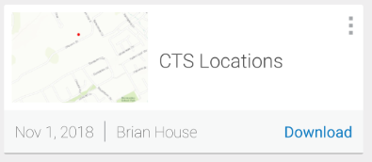

**1**

Click on the  icon to download the map.

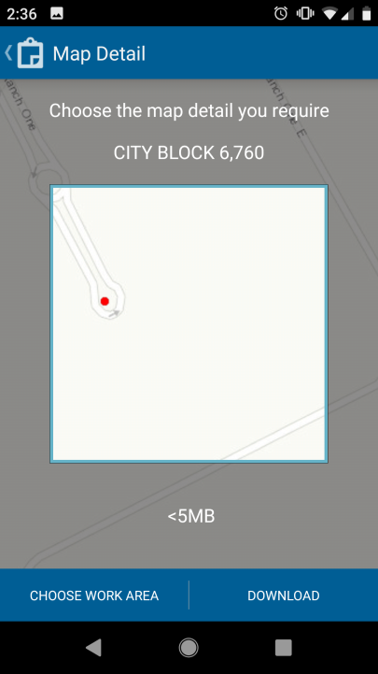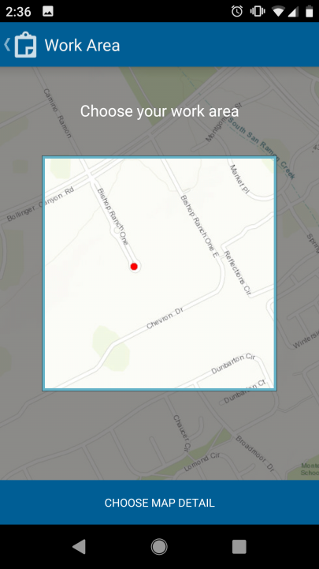

**2**



**Upload/Sync Offline Maps**

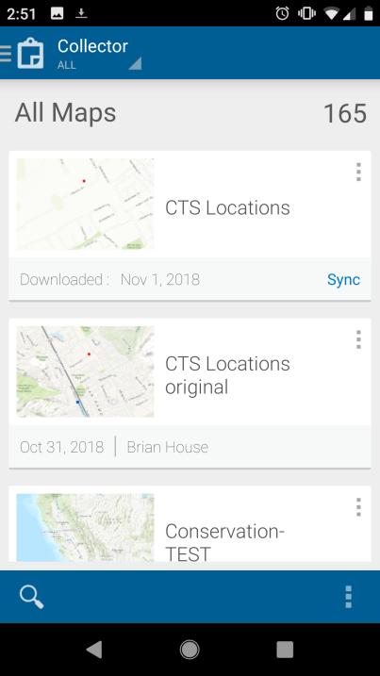

**3**

Sync means the map is now downloaded onto your device and is ready to sync

Syncing your offline activity

If you are working offline or ‘On Device’, be sure to sync your data once you have re-established either cellular service or have a WiFi connection. Once you have finished syncing all your offline maps, you can delete the saved maps from your device.

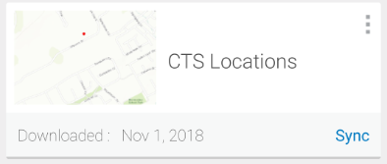

**1**

Select Sync submit the features added offline to ArcGIS Online.



**Upload/Sync Offline Maps**

If you are working online, connected to ArcGIS Online with WiFi or cellular data, you do not need to sync because it is done every time you select submit.

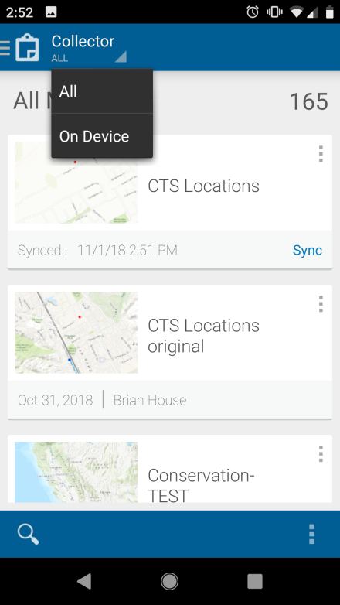

2

Click here and select “On Device” to delete the map off of your device once you have completed synced to ArcGIS

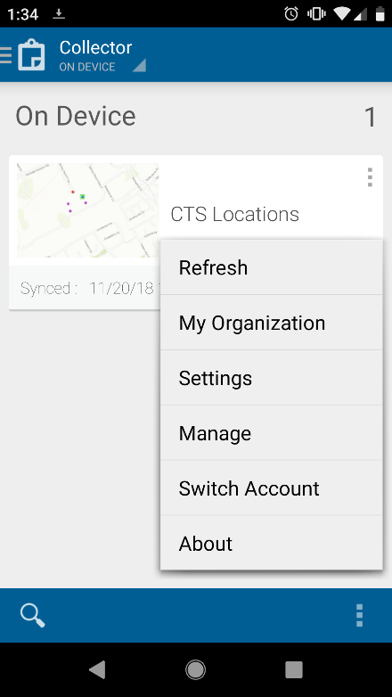

3

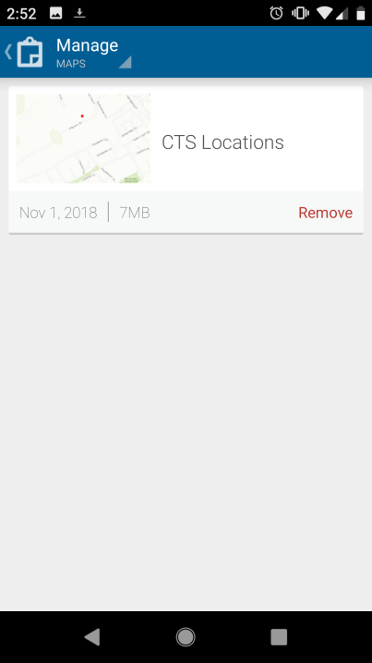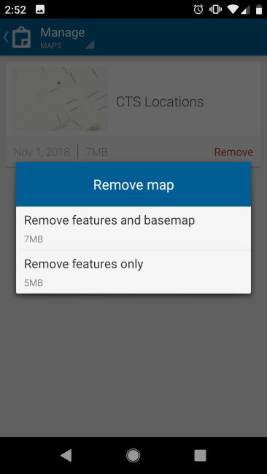

**4**

Select “Remove”

Select Overflow and then

Manage.

Select “Remove features and basemap” to delete the map from your device

**NOTE: DO NOT REMOVE DOWNLOADED MAP**

**UNTIL ALL DATA IS UPDATED AND SENT IN SURVEY123.**

# Collecting Data

## ArcGIS Collector



**Symbols**

**Legend**

### Summary

Below are the meanings of the symbols and colors that are seen throughout the map as you input the information for each layer.

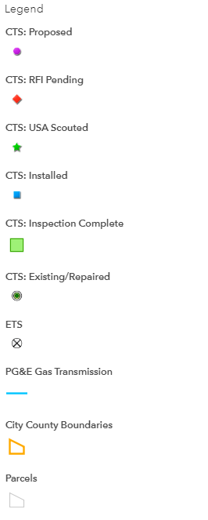



**Editing Data**

**Map Layers**

1. Search for specific CTS Location 2. Select the Pin icon or List to identify the specific

CTS location that needs to be edited

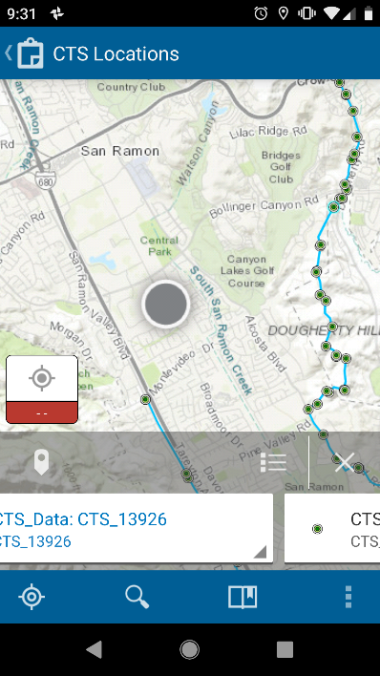 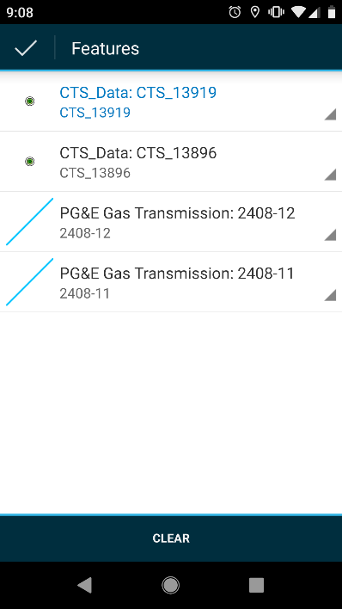

Pin Icon List

3. Select specific CTS Location to 4. Fill out all the pertinent data within collector  
 open details and select edit before going into Survey123

Edit 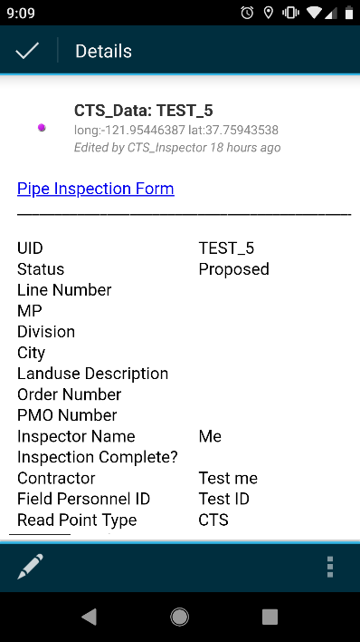 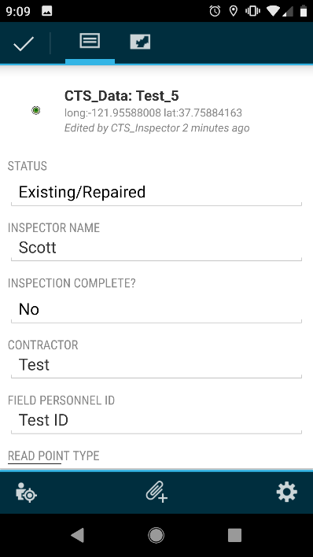



**Editing Data**

**Map Layers**

5. If a CTS location is incorrect and needs to be moved:

- Select map icon (this will highlight the CTS point)

- Hold finger down on the screen in order to move the CTS location to the correct area

Map Icon

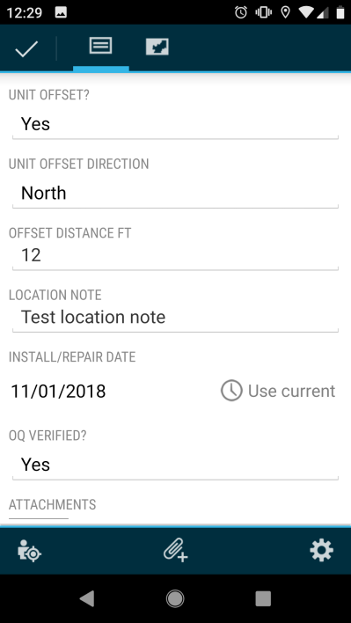 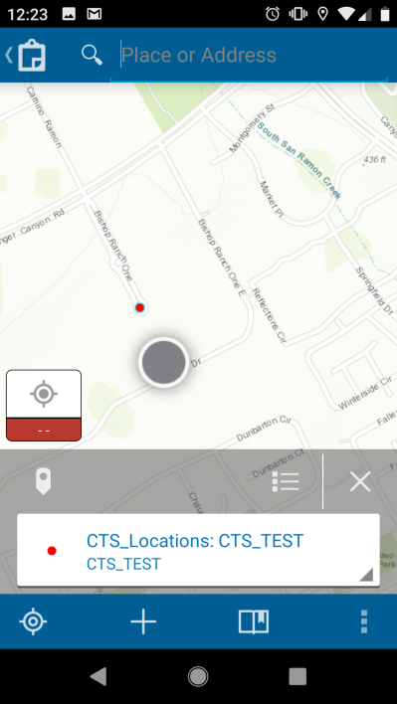

6. Select the camera button 7. Select camera, take photo (do not choose from gallery),  
 to take a photo click on photo and rename, and select checkmark

 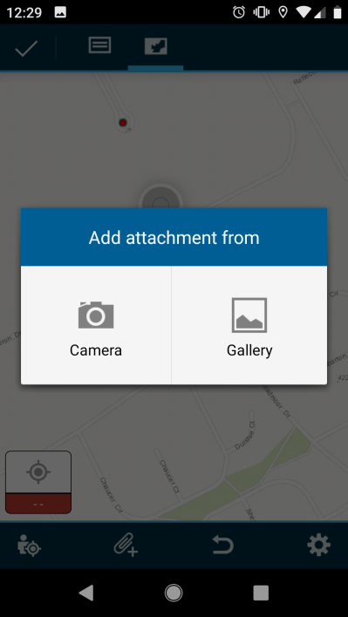

Camera Button



**Editing Data**

**Map Layers**

8. Types of photos to be included:

**- Pre-construction**: This will be a picture of the site before any disturbance has occurred

**- TOP prep**: this will be a picture of the site before any disturbance has occurred

**- Cad-weld or Pin Braze**: this label will depend on which applications were used

and self-explanatory.

**- Handi cap or Hot wax**: this label will depend on which application was used and

self-explanatory.

**- AC measurement**

**- DC measurement**

**- CTS Terminated**: this is a picture of the wires terminated in the post head

**- Restoration**: this is a picture of the area restored and completed

**- Pre-dig**

**- Project documents**: (Optional) any other documents that may be pertinent to the install

JSA, Hot work, excavation report, Asbestos chain of custody, coating report if Hot wax was

used, etc.

 9. Once all edits are complete, select checkmark

# Inspectors Only -Collecting Data

## Survey123

**Inspectors Only - Collecting Data Survey123**

1. Within Collector, select Pin or List Icon 2. Select Pipe Inspection Form hyperlink

and select specific CTS Location from the Details page in Collector in

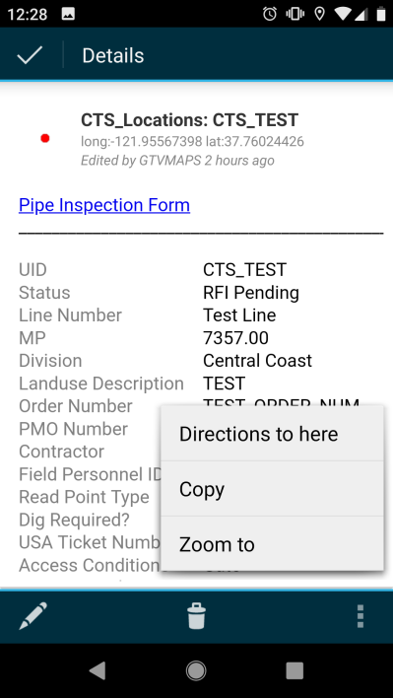 order to open Survey123

2. Fill out all information. There 3. Select checkmark when complete.  
 shouldn’t be any blank fields.

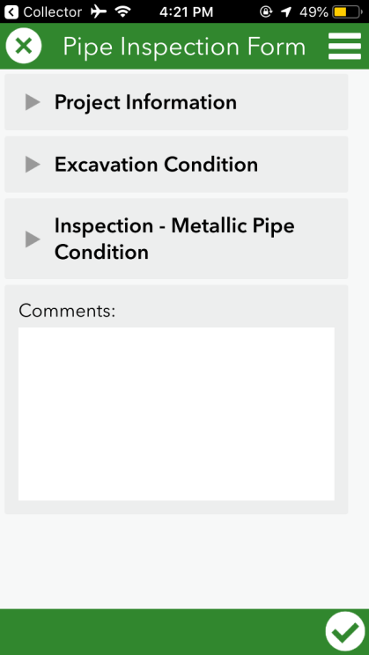 Checkmark



**Inspectors Only - Sending Data (online)**

**Survey 123**

1. Select ‘Send Now’

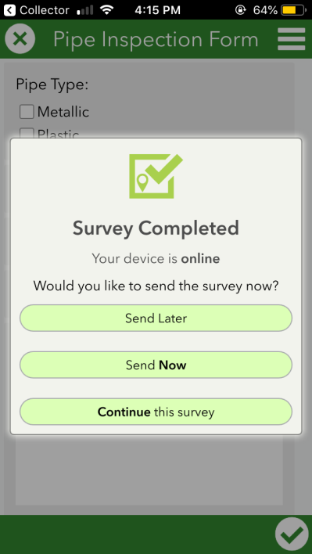



**Inspectors Only - Sending Data (offline)**

**Survey 123**

1. Select ‘Send Later’ 2. Once you’re back in service, go to  
 My Surveys and select Pipe Inspection  
 Form. There should be a ‘1’ in the corner.

 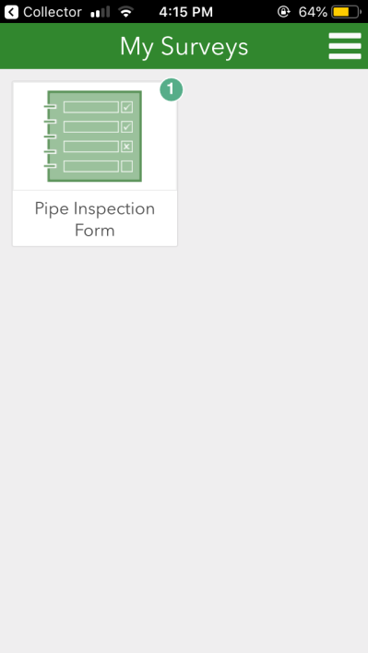

3. Select Outbox 4. Select Send

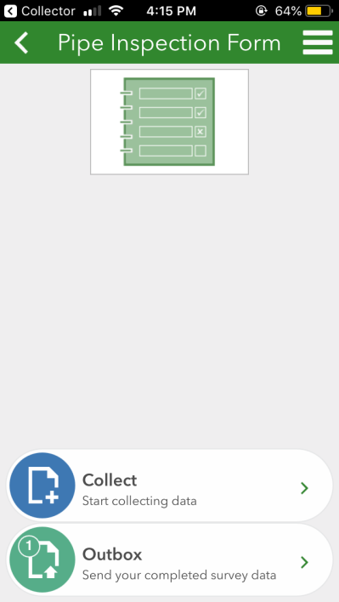 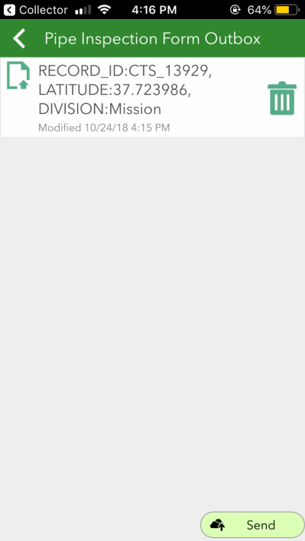



**General Workflow**

1. Crews will use the web map titled “CTS Locations” to collect data. If the work site is in a location  
outside of cellular service, the map area must be downloaded to a device prior to being offline.

2. Within the “CTS Locations” web map, crew will navigate to appropriate CTS data point and begin

collecting data

-All editable fields should be collected

3. If RFI is needed, the crew sets status of point to “RFI Pending” and moves the location of the

point to where the actual install will take place

4. Record the reason for the RFI in comment section

5. Construction Manager will assess the “RFI Pending” point and change the status to “Proposed”  
 once it is approved on the Shovel Ready Report

6. Crew will collect the following photos and attach to the point data in collector

**- Pre-construction**: This will be a picture of the site before any disturbance has occurred

**- TOP prep**: this will be a picture of the site before any disturbance has occurred

**- Cad-weld or Pin Braze**: this label will depend on which applications were used

and self-explanatory.

**- Handi cap or Hot wax**: this label will depend on which application was used and

self-explanatory.

**- AC measurement**

**- DC measurement**

**- CTS Terminated**: this is a picture of the wires terminated in the post head

**- Restoration**: this is a picture of the area restored and completed

**- Pre-dig**

**- Project documents**: (Optional) any other documents that may be pertinent to the install

JSA, Hot work, excavation report, Asbestos chain of custody, coating report if Hot wax was

used, etc.

7. Inspector will use the web map titled “CTS Locations – Inspector” to collect data and access the  
 pipe inspection form.

- Within this map, the inspector will fill out the “Inspector Name” and “Inspection Complete”  
 fields

8. Inspector will follow “Pipe Inspection Form” hyperlink to fill out/submit the Survey123 Form

# Links and Resources

## ArcGIS Collector and Survey123



**Links and Resources**

Questions related to Collector (adding and editing features, layers, etc.) can be directed to the following email address:

[S5LZ@pge.com](mailto:S5LZ@pge.com)

Questions related to logging in or resetting passwords can be directed to **TSC Support** at the following number: 415-973-3411.